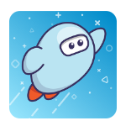 | Sora is the CMS ebook platform for academic, professional, & leisure reading!

SORA SETUP  To set up Sora  Add two additional libraries  Trouble-shooting Tips  Find EL books by Module | SORA NAVIGATION  Preferences  Explore  Collections  Search  Hold Settings | OTHER/MISCELLANEOUS  Shelf  Me  Menu/Help  Sharing a specific title

SORA SETUP
To set up Sora:
- Go to soraapp.com OR download the app (Sora by OverDrive available in the App Store or Google Play) on your device. The steps are the same either way.
- Click Find My School.
- If Charlotte Mecklenburg Schools isn’t one of the schools that pops up, click My school isn’t listed at the bottom of the screen, then type in Charlotte OR your School Name (either works!)
- On the drop down window that appears, choose Charlotte-Mecklenburg Schools.
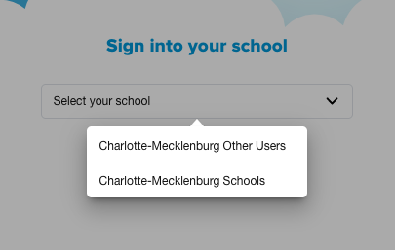
- Select Charlotte Mecklenburg Schools or Your School, then follow the prompts to login. You will have three options (shown below). One of the first two options should work for you. Do not use the third option.

Add two additional libraries:
Once logged in to your CMS account, follow these steps to add two more libraries you access all from the same app:
- Select Dropdown at the top of the screen, OR the hamburger/options menu in the top right corner, and select Add a Public Library
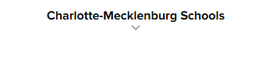 OR | 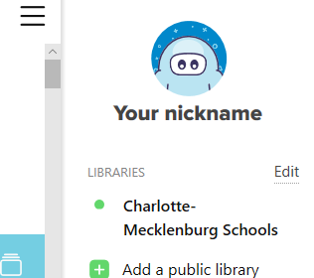
- Type Charlotte again and scroll to/select the Charlotte Mecklenburg Library. The first time you check out a book from the Public Library you’ll need to log in using your ONE Access ID:
  - Students: Student ID
  - Staff: CMS+NC EdCloud ID (cmsxxxxxxxxxx)
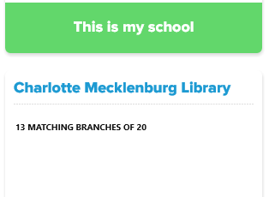
- Follow step 1 again, then type in NC and select NC Kids Digital Library.
- The first time you borrow a book from NC Kids you’ll need to log in using your Clever credentials - make sure you select Charlotte Mecklenburg Schools from the drop down menu.
Trouble-shooting Tips:
- If the directions above do not work for you, try logging into NCEdCloud, then Clever, then Sora and attempt it again starting at Step 2 above. Do this before requesting assistance from the CMS Technology Services Help Desk.

- Problem: You get into a cycle where your info seems to work but it keeps directing you back to the log-in screen. *Note: this seems to happen more often with district staff who are not directly affiliated with schools. Overdrive is aware and working to resolve the issue.
Solution: Clear your cookies, close your browser completely, then open it back up and try again. If that does not work, try logging in on a separate device (try using the Sora app on your phone). If you continue to be stuck in this cycle, email kimberlys.king@cms.k12.nc.us.

- Problem: You get a yellow screen that reads “Page Error.”
Solution: Try the same steps described for problem number 2, and email kimberlys.king@cms.k12.nc.us if the problem continues.

- Problem: If you get an Uh oh! screen, it may mean you are not in PowerSchool as an active member.
Solution: Have your school level PowerSchool data manager check to see if you are active. If not, they can add you to PowerSchool as an active staff member. After PowerSchool syncs with Clever overnight, you should be able to follow these directions and get in. If you are already active on PowerSchool, move to step 3.
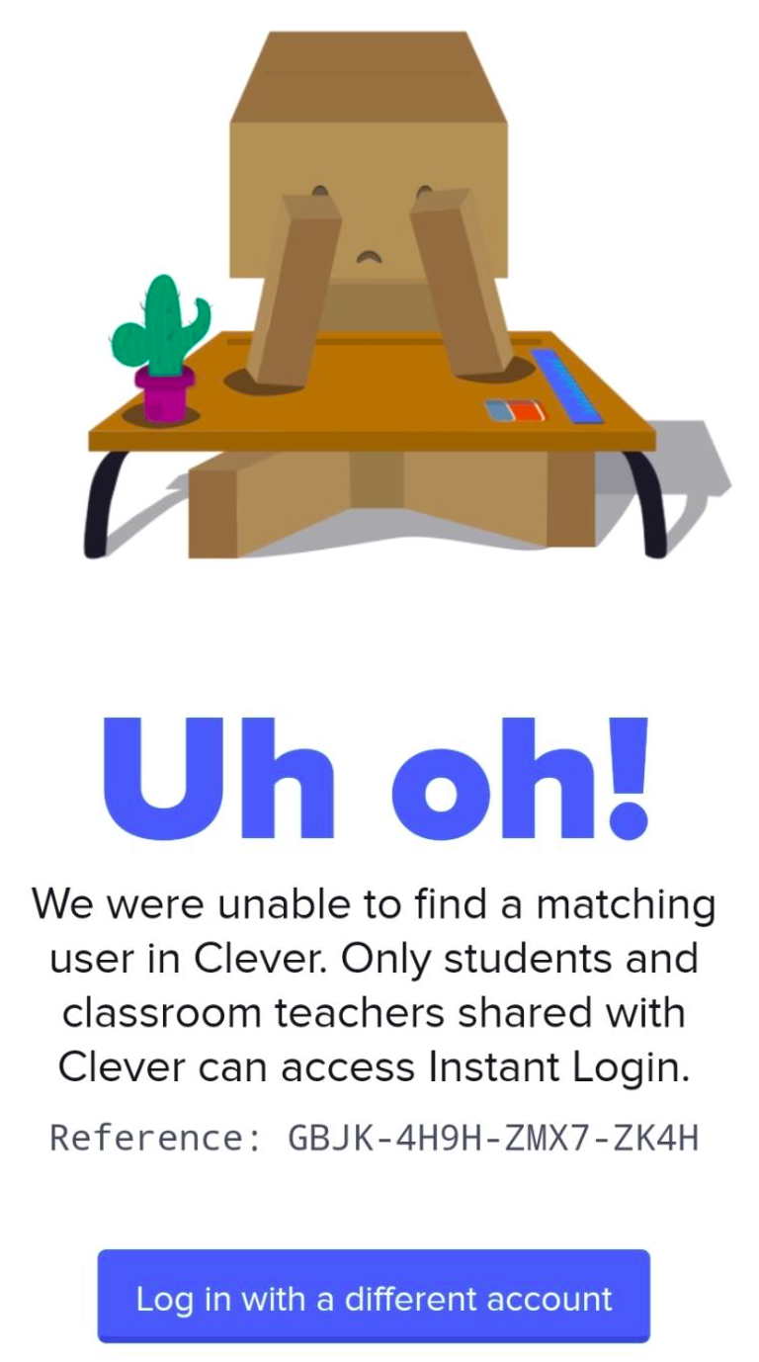
- Submit a ticket through Cherwell -> Canvas and Clever -> Issues with Clever Applications.
Make sure you include that you are trying to access Sora.
Find EL books by Module:
- Click on Explore at the bottom of the screen to get to the Charlotte-Mecklenburg Schools home screen.
- From the Charlotte-Mecklenburg Schools home screen (shown below), click on Collections.
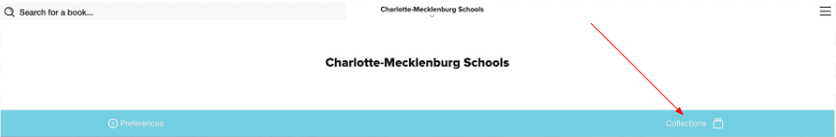
- From the Collections list, select the Grade/Module that you want. For example, K mod 3 - Trees are Alive contains the recommended and required reading that is available in ebook format for Kindergarten module 3.

SORA NAVIGATION
Once you have set up your Sora account, you are now ready to navigate and explore the wealth of resources. There are several ways to search for books. Use one or more of the following options.

Preferences
- Before you start searching, you may want to limit the books that appear for you. To do this, use the navigation buttons along the bottom menu to locate the Explore menu.
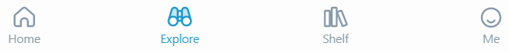
- From the Explore screen, click on the word Preferences in white.
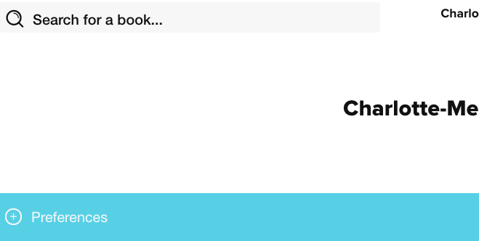
- You’ll now be able to adjust preferences, including if you want to search for just ebooks or just audiobooks, if you only want to see books that are available (instead of books you may have to put on hold), or any of the other options shown below.
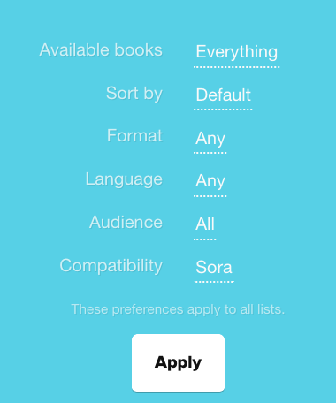

Explore
- Use the navigation buttons along the bottom menu to locate the Explore menu.
- You are now ready to begin exploring resources. Some options you may see as you scroll down the page are:
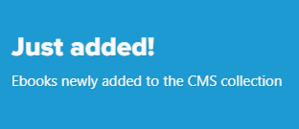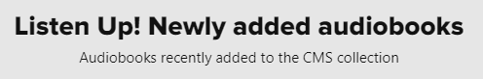
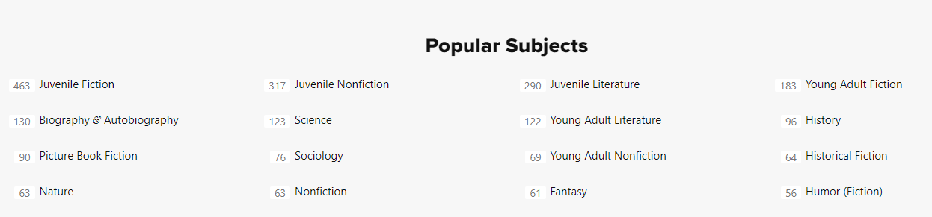

- Explore books by Popular Subjects or select the Explore all subjects button.

Collections (CMS Modules)
- From your Explore screen, select the Collections tab on the right side to explore CMS Modules.
- The modules have been created to align with district literacy and curriculum adoption resources. For example, 1st mod 1 - Tools and Work corresponds to first grade Module 1.
- Of particular note is the Professional Development Collection. A curated and continuously growing collection of professional titles is available to CMS staff.
- Clicking on the module title will take you to the ebooks for that module. Use the Refine tab on the right side to refine your search. 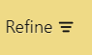
- Click on the image of the book to learn more, read a sample, add the title to a list, or borrow the book.
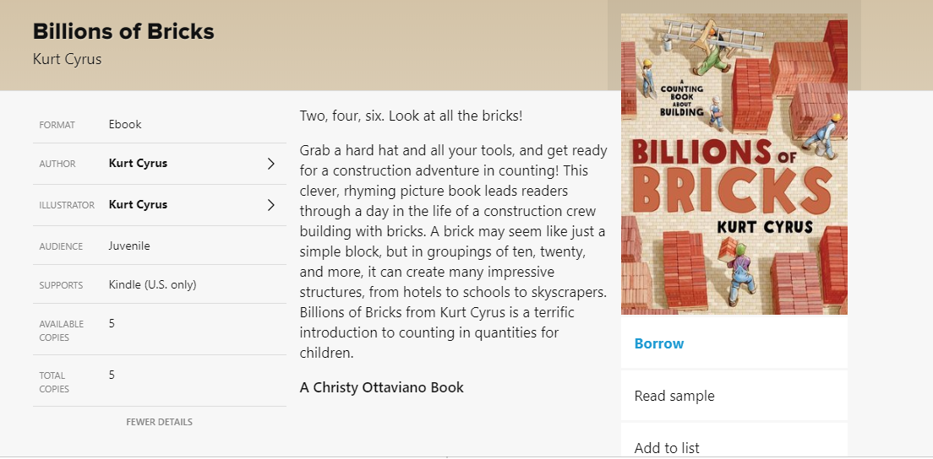

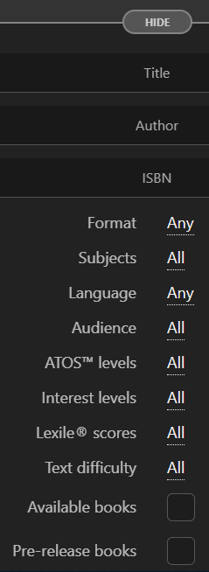
Search
- The search feature is imbedded in Sora and may be accessed in the upper left corner of the Explore menu. Simply enter the title, author, or ISBN for the book. 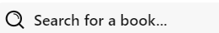
- Be sure you include all of your libraries (Charlotte Mecklenburg Library, NC Kids Digital Library, etc.). 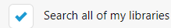
- You also have the ability to conduct an Advanced Search which allows you to further refine your search by format, language, Lexile, text difficulty, etc. and other parameters. For example, if you only want to see audiobooks, change the “Format” to “Audiobooks.”

Hold Settings
- You can adjust the hold settings on your account by clicking on the menu (three stacked lines) in the upper right corner.
- From there, click on Hold Settings by the bell, then adjust the settings you prefer based on whether you want holds to download automatically, or if you want to continue to move up on the hold list but hover in the first position in line for a set period of time until you’re ready to check it out. Make sure you click Update All Holds before you click Done!
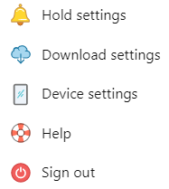
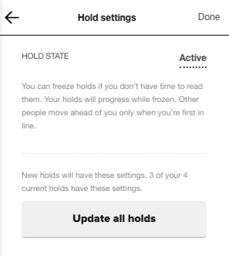

- When your hold is ready, you’ll see a notification in the top right corner of your screen. When you click on it, you have the choice to check your book out right away or to extend your hold until you’re ready.
OTHER/MISCELLANEOUS
Shelf
Your Shelf is where books you have borrowed will be located. You can search your shelf by loans, holds, lists, and activity.
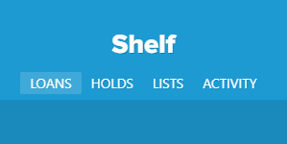

Me
The Me section is about you, the user. You can keep track of the books you have opened and read, the average time it takes to read, streaks, achievements, etc.
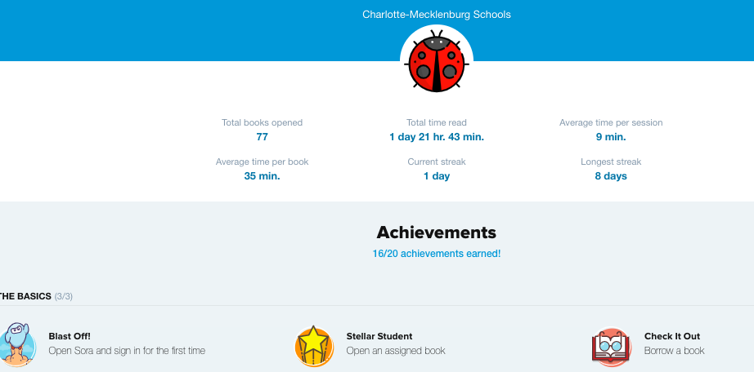

Menu / Help
If you ever lose your way, just select the menu (three stacked lines) in the upper right corner.
You have access to Settings, Help, and other features.

Sharing a Specific Title
To send a title directly to another Sora user:
- Go to Sora on your browser, and click on the cover of the book so that it opens the info page for that book (do not click “Borrow”).
- Select the address in the address bar, and copy it. (Control C)
- Share that address with the other user. If they are already logged in to Sora it will take them directly there. If not, they will be cued to log in, and then will be directed to that page once they are logged in.
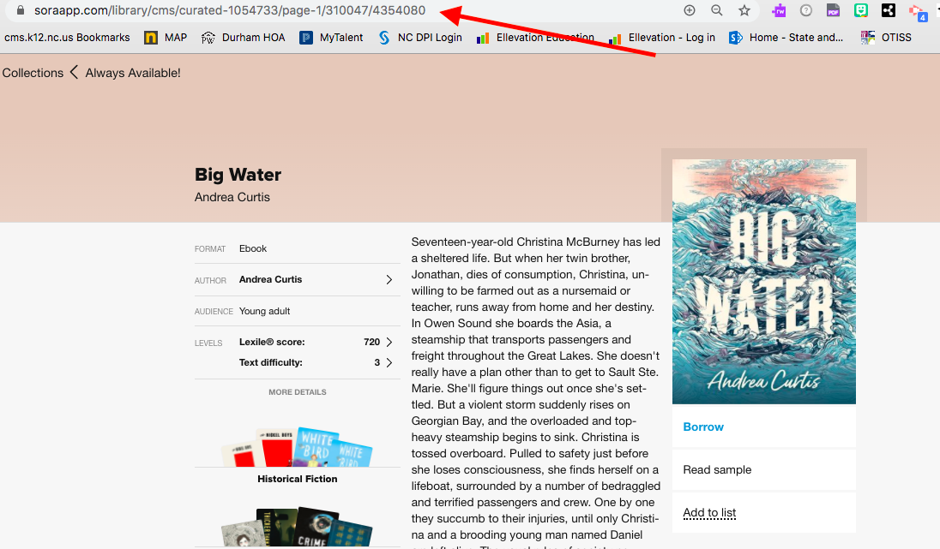
- Note: If you share a title from the “Always Available” collection in this way, your student will be able to check the book out right away. Any other title, it is possible that they will need to “Place Hold” if all of the copies are currently checked out.
If you need your student to have longer access to a title, or if sharing a title as described above is not an option, your media coordinator can assign a title to a user from the Overdrive Marketplace Advantage Account. Please see them for this option if necessary.

